Software Testing Assignment

Module–1(Fundamental)

1) What is SDLC

→SDLC is structure that is imposed in the software development that define process of

planning, implemnetaion, testing, documentation, deployment, ongoing maintenace

and support. OR

The software development lifecycle (SDLC) is the cost-effective and time-efficient process that development teams use to design and build high-quality software.

2) What is software testing?

→Software testing is the process used to identify the correctness, completeness, and quality of

a developed software.

3) What is agile methodology?

→Agile is a combination of incremental and iterative model. It focuses on adaptability and

customer satisfaction. Team divides the product in to smaller incremental builds.

4) What is SRS

* A software requirements specification (SRS) is a complete description of the behavior of the system to be developed.
* It includes a set of use cases that describe all of the interaction that the users will have the software.

5) What is oops

OOPS :- Object Oriented Programming Systems

* Identifying objects and assigning responsibilities to these objects.
* An object is like a black box.
* The internal details are hidden.

6) Write Basic Concepts of oops

Basic concepts of oops are give n below:

• Object

• Class

• Encapsulation

• Inheritance

• Polymorphism

• Abstraction

7) What is object

Object :- is an instances of an class

: To create memory for that class to access all the priorities of an class except private

Sy:

Classname objectname=new classname();

8) What is class

Class :- is an collection of data member (variable) and member function (process, methods) with its behaviour i.e

Sy:

Class classname

{

Datamember

Member function

}

9) What is encapsulation

Encapsulation:- data hiding : wrapping of data into single unit i.e

:Private your data member and member function

10) What is inheritance

Inheritance:- properties of parent class extends into child class

:Properties of superclass extends into subclass

:Main purpose is extendibility, reuseability

:There are mainly 5 types

1. Sngle
2. Multilevel
3. Hierarchical
4. Multiple: java does not support directly
5. Hybrid: java does not support directly

11) What is polymorphism

Ability to take one name having different forms

:Multiple forms, many forms

:there are mainlt 2 types

1.Method overloading

2.Method overriding

12) Draw Usecase on Online book shopping

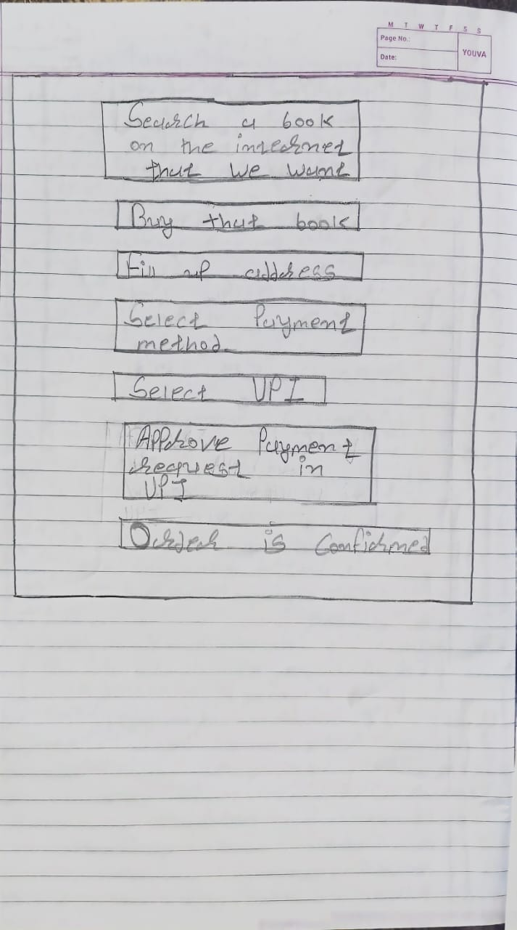

13) Draw Usecase on online bill payment system (paytm)

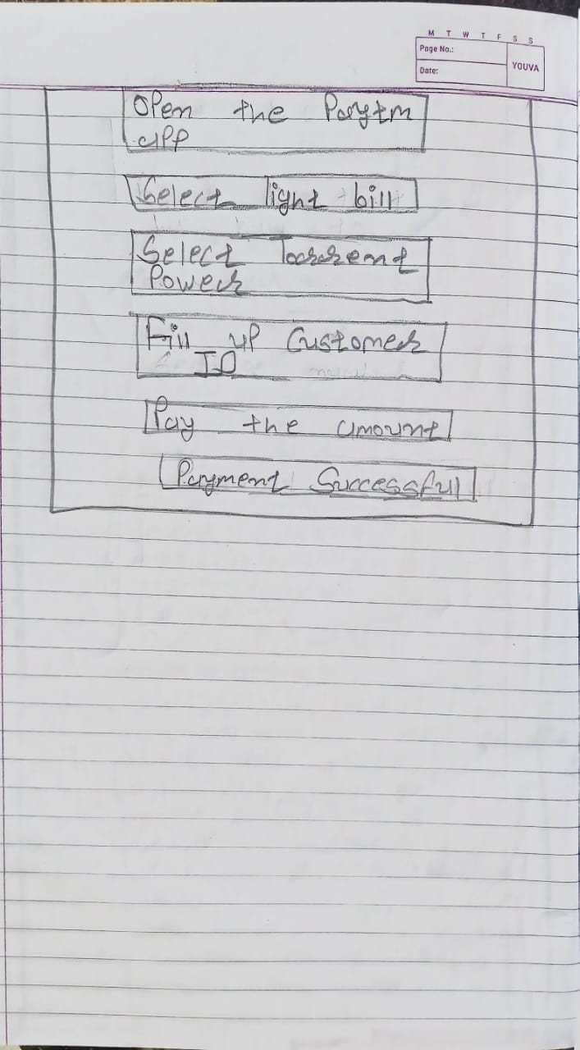

14) Write SDLC phases with basic introduction

→

1.Requirement

Customer Requirement inlcude Features and Usage Scenario

Requirement can be Documented in Written Form. It may be Incorrect, incomplete and

unambiguious

2.Analysis

In Analysis Phase Analyse the System requirement, independent of Requirement can be

accomplised

Analysis phase is also called What Phase.

3.Design

Design Architecture Document

Test Plan

4.Test

Here Quality is vey important and many companies have not learned about it yet and they still

produced low level Quality

5.Implementation

Implementation phase where team builds component either Document from Design Phase and

Requirement document from Analysis Phase

6.Maintenance

There are Three Maintenance:

Corrective Maintenance

Adapative Maintenance

Perfective Maintenance

15) Explain Phases of the waterfall model

→It has different SDLC phases

Requirement

Analysis

Design

Implementation

Testing

Maintenance

-The Waterfall is one way model where there is no backward.

-Requirements are frozen early in the life cycle

-The Project is short

PROS

-Simple and easy to use and understand

-Easy to manage due to high rigidity of the model

-Easy to arrange Task

-Results are well documented

CONS

-High Amount Risk and Uncertainty

-Model is not good long and ongoing process

-Model is not good Complex and object oriented project

-It is not flexible and not responding to change.

16) Write phases of spiral model

→ There are four phases -

1. Planning :-determination of objectives, alternatives and contraints

2. Risk analysis :- Analysis of alternatives and identification/ resolution of risks

3. Engineering :- Assessment of the results of engineering

4. Customer Evaluation :- Development of the “next level” product

17) Write agile manifesto principles

→There are four phases

1. Responding to change

2. Working Software

3. Individual interaction

4. Customer collaboration

18) Explain working methodology of agile model and also write pros and cons.

→Agile is combination of incremental and iteration model

* It focuses on adaptability and customer satisfaction.
* It divide the product into smaller increment builds.
* Each iteration typically lasts from about one to three weeks.
* customer and important stakeholders.
* At the end of the iteration a working product is displayed to the

🡪 In agile the tasks are divided to time boxes to deliver specific features fora release.

Pros:-

* Is a very realistic approach to software development
* Functionality can be developed rapidly and demonstrated
* Delivers early partial working solutions
* Suitable for fixed or changing requirements
* Good model for environments that change steadily.
* Resource requirements are minimum

Cons:-

* Not suitable for handling complex dependencies.
* More risk of sustainability, maintainability and extensibility.
* Strict delivery management dictates the scope, functionality to be delivered, and adjustments to meet the deadlines.
* There is very high individual dependency, since there is minimum documentation generated.
* Transfer of technology to new team members may be quite challenging due to lack of documentation use – case

19) Draw usecase on Online shopping product using COD.

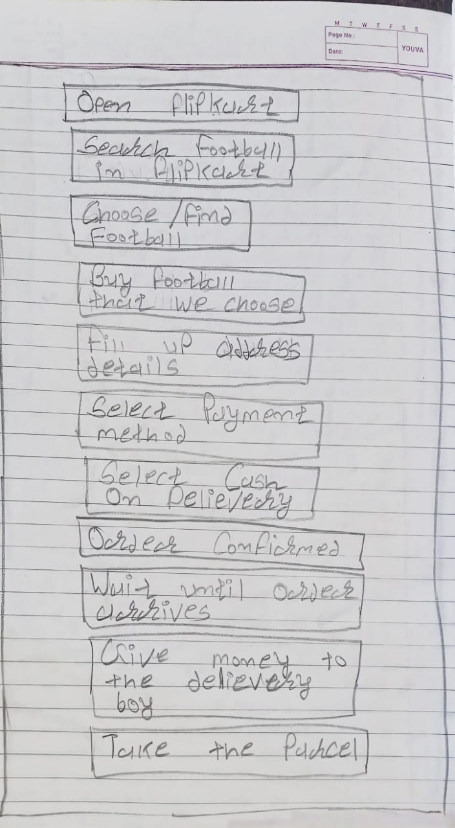

20) Draw usecase on Online shopping product using payment gateway.

